

**Informatics College Pokhara**



**Artificial Intelligence -CU6051NI**

# Individual Coursework-1

**Submitted** **To**:

Mr. Abhinav Dahal

Module leader

Artificial Intelligence

**Submitted** **By**:

Name: Milan Tilija

London Met ID: 20048683

Group: C2

Date: 10/12/2022

# Acknowledgement

To finish this coursework, I would want to enlist the support and guidance of a few people. Without the cooperation and supervision of Mr. Abhinav Dahal, Mr. Mahesh Dhungana, the module leader and tutor at Informatics College Pokhara, this project would not have been feasible. I am appreciative of everyone's cooperation during this coursework.

The people in my family have been more significant to me in the pursuit of this project than anybody else. I want to thank my parents for their support and love in whatever I do. They are the ultimate role models.  Most of all, I want to thank my loving and supportive mother.

Table of Contents

Individual Coursework-1 1

1. Introduction 1

1.1 Introduction to AI and Types 4

1.2 Explanation of the topic 8

1.3 Explanation of the chosen problem domain 10

2. Background 12

2.1 Research works 13

2.2 Review and Analysis of existing work in the problem domain 21

3. Solution 27

3.1 Explanation of the proposed solution/approach to solving the problem 27

3.2 Explanation of AI Algorithms used 27

3.3 Pseudocode 32

4. Conclusion 33

4.1 Analysis of work done 33

4.2 How the solution addresses the real-world problem 33

4.3 Further work 34

References 35

Table of Figure

Figure 1 Artificial Intelligence 1

Figure 2: Recommendation system. 3

Figure 3: Types of artificial intelligence. 4

Figure 4: IBM's Deep Blue system and Garry Kasparov playing chess. 5

Figure 5: Limited Memory: self-Driving car. 6

Figure 6: Theory of Mind: Kismat and Sophia 7

Figure 7: Types of collaborative filtering recommendation system. 9

Figure 8: Movie Recommendation system. 11

Figure 9: Website 1. 13

Figure 10: Website 2 . 14

Figure 11: Website 3. 15

Figure 12: A Survey on Recommendation System. 16

Figure 13: Movie Recommender System Using Collaborative Filtering. 17

Figure 14: Recommendation System: Principles method and evaluation. 18

Figure 15: Recommender Systems Handbook. 19

Figure 16: An improved content based collaborative filtering algorithm for movie recommendations. 20

Figure 17: Netflix 21

Figure 18: Prime Video 22

Figure 19: MyFlixer 23

Figure 20: Flickmetrix. 24

Figure 21: WeWatch 25

Figure 22: Movie of the night. 26

Figure 23: Zoro.to 27

Figure 24: KNN Classifier. 29

Figure 25: K Nearest Neighbor (KNN) 30

# Introduction

With good reason, AI is presently one of the most popular terms in technology. Over the past several years, several advancements and innovations previously only seen in science fiction have progressively become realities. Artificial intelligence (AI) and digitalization are changing how we work, live, communicate, learn, and play. We, humans, are increasingly using enhanced technologies like AI in our daily lives which may also have a substantial impact on our lives. AI is revolutionizing all aspects of human existence. The first AI thought to be a checker-playing computer was developed in 1951 by Christopher Strachey, Oxford University UK. (Copeland, 2022).

Artificial intelligence (AI) is the simulation of human intelligence in machines that are programmed to perform tasks commonly associated with intelligent beings and mimic their actions. (FRANKENFIELD, 2022). For instance, Siri is one of the most famous inventions in the technology world. Siri is a voice recognition that can understand natural human language and performs a task like answering a question, reading messages, searching on the internet, and many more which reduce time and complexity. Machine learning is one of the subsets of artificial intelligence which can automatically learn from and adapt to new data without being assisted by humans. The ideal characteristic of AI is to the ability to justify and take actions to achieve the specific targeted goals.

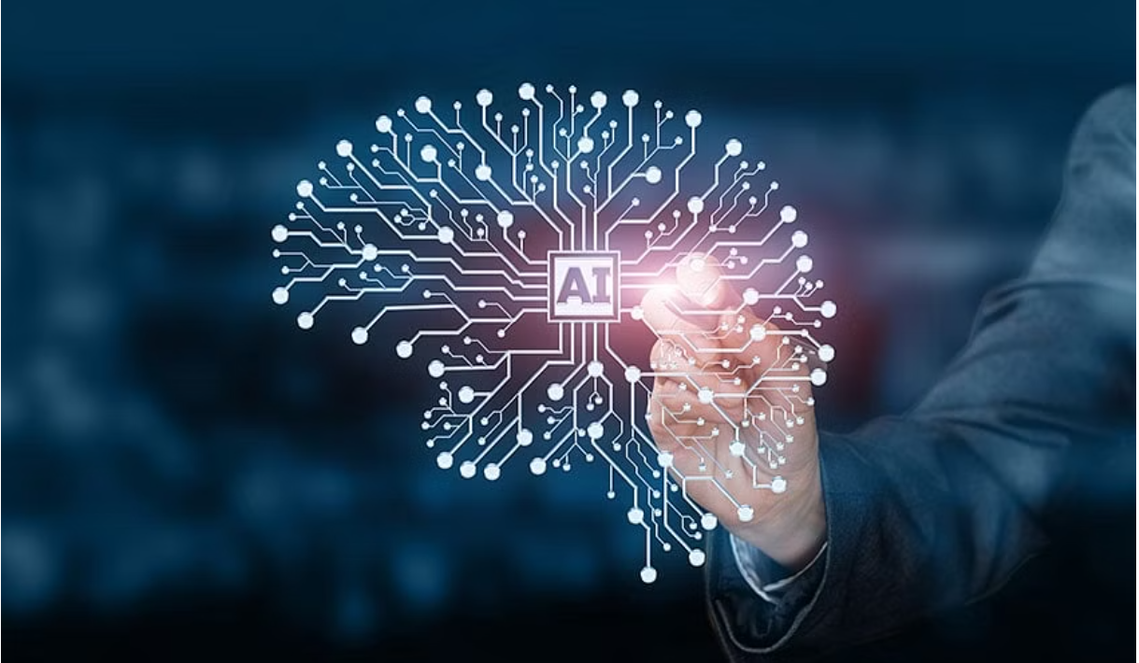

**Figure 1 Artificial Intelligence**

AI has now actively worked in every sector like farming, large industries, and even in coding world. We can look at the close example of GitHub Copilot which is trained using free open-source repositories of GitHub. This system predicts what the programmers wants to write, and which function he/she wants to complete. AI inventions are just begun and those technologies are being tested in various fields. Some of the most renowned applications of AI are in the healthcare industry for dosing drugs and doling out different treatments tailored to specific patients. Auto-playing chess and autopilot like Tesla have become one of famous technologies invented. Artificial intelligence has applications in the finance industry, which helps banking and finance to regulate the economic flow of money. (FRANKENFIELD, 2022)

In this time AI has become the most important thing in the whole world. Artificial intelligence allows a system or computer to learn, reason, and correct itself as needed.AI can significantly reduce errors and increase, accuracy and precision based on information gathered and a certain set of algorithms. AI is available anytime as it doesn’t feel tired, weak, or stressed. The productivity of products and profit of the company can be boosted by AI certain inventions like recommendation systems, and chatbots for a frequent response. More and more national arrangements are centering on AI, which is being consolidated into and affecting mechanical and agricultural forms, administrations, esteem chains, and the organization of work environments. AI has the potential to improve people’s lives, but it too raises several important approaches, moral and social issues, counting job creation and work out-of-date quality. It speaks to a source of social and political pressure, and dangers exacerbating inequalities inside and over nations. (Duggal, 2022).

This project is all about conducting research on one particular AI issue among several AI topics. Recommendation systems, a highly popular and frequently used AI concept, are studied in this study. For developing recommendation systems, there are several approaches and algorithms. Collaborative filtering, one of the most widely used algorithms. In this algorithm, similarities between users and specific items are used to recommend products and items to another person. Today, recommendation systems are utilized extensively on streaming websites like Netflix and YouTube as well as commerce sites like Amazon, Daraz, others.

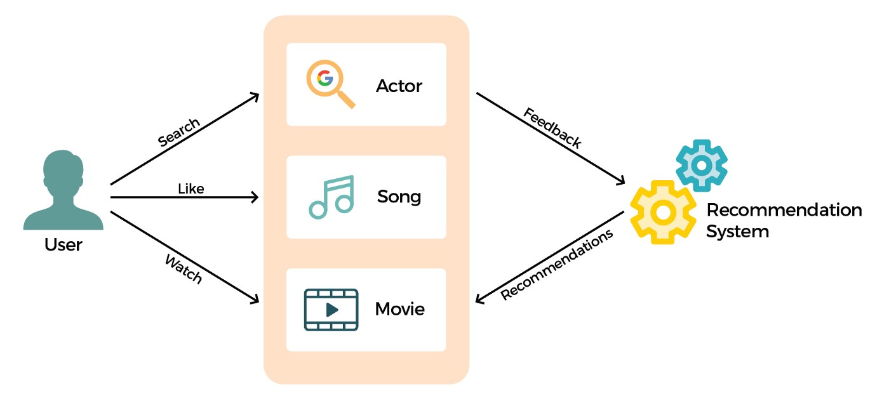

**Figure 2: Recommendation system.**

## Introduction to AI and Types

AI research aims to guide machines to mimic human-like functions, so the extent to which an AI system can mimic human capabilities is used as a criterion for determining the type of AI. There are two general classifications for AI based on this criterion. One approach is to categorize AI and AI-enabled technologies according to their resemblance to the human mind and their ability to "think" a maybe "feel" like humans. Thera are tow main category of artificial intelligence based on capabilities and functionality. Under capabilities AI based system, weak AI, General AI and Strong AI are three of them. Likewise, reactive machines, limited memory machines, theory of mind, and self-aware AI are categorized under functionality-based system. (Biswal, 2022)

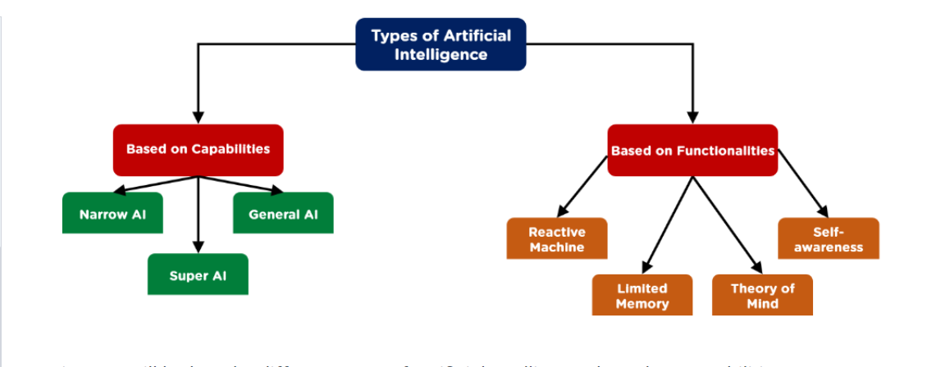

**Figure 3: Types of artificial intelligence.**

**Weak AI** is also known as narrow artificial intelligence which describe that it is limited to a specific or narrow area. They can do narrow task and cannot perform beyond its limitation. It can simulate human cognition like learning, perception, reasoning, problem solving and other activities that a human can perform. By making predictions and detecting patterns weak AI helps in converting big data into usable information. Facebook newsfeed, Amazon’s suggested purchase, IBM Watson supercomputer and Apple’s Siri, that response user’s commands are some of the example of weak AI. (Frankenfield, 2022)**. Strong or general AI and super AI** is only the theoretical AI at this point. When a machine will have full cognitive abilities, doesn’t required human for instructing machine, and machines act, feel, respond and think like humans. (Marr, 2021).

Some other types of Artificial intelligence categorized based on their functions are:

1. Reactive Machine

Reactive machine like IBM’s Deep Blue system and Google’s AlphaGo doesn’t store memories or past experience for future references. They operate solely based on the present data and perform a narrowed range of tasks. This type of AI is programmed in such way that output is predicated based on the input it receives. (Marr, What are the Four Types of AI?, 2022)

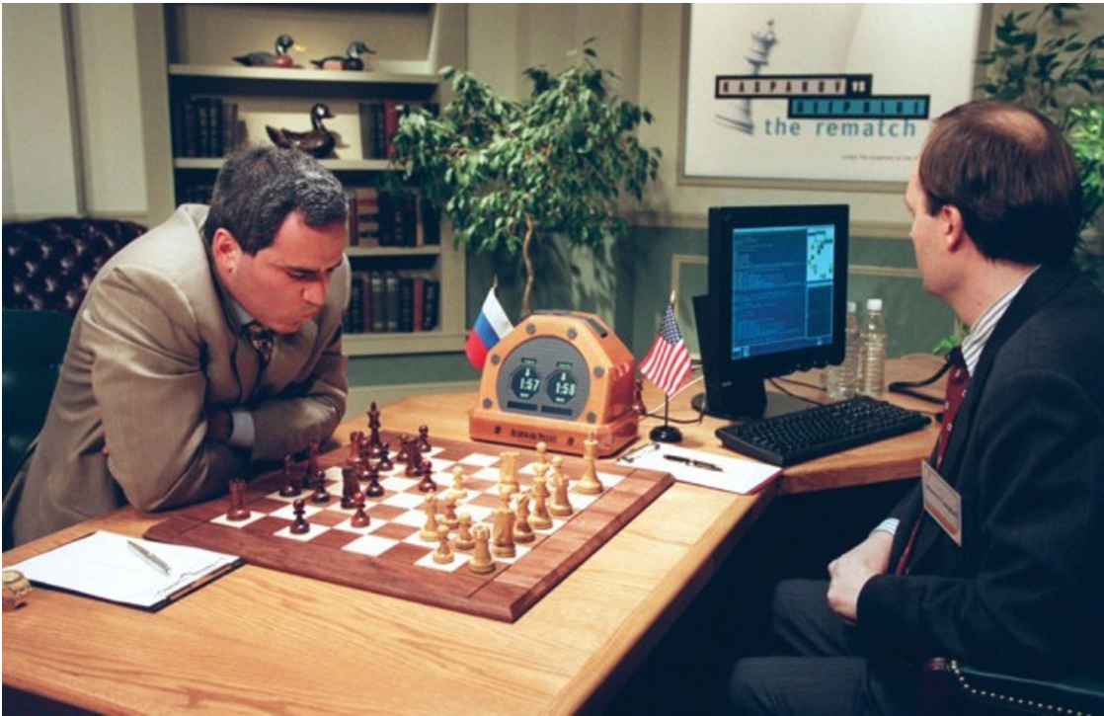

**Figure 4: IBM's Deep Blue system and Garry Kasparov playing chess.**

1. Limited Memory

Like name, this type of AI can store memories and data for shot period of time which trains to make informed and improved decisions by evaluating the past data from its storage. Self-driving is one of the examples of limited memory system. Information like speed limit, identify people crossing the road, steep roads, traffic signals are stored in memory for short time period and helps to happen accidents. (Lateef, 2022)

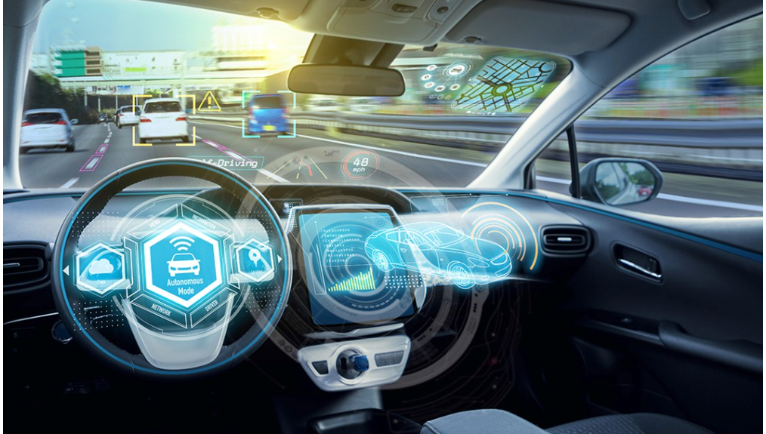

**Figure 5: Limited Memory: self-Driving car.**

1. Theory of Mind

The Theory of Mind is the most advanced technology which exits only as a concept. According the researcher’s thoughts, this kind of AI can understand human emotions, people, beliefs and able to understand human. The major focus of this sort of AI will be emotional intelligence, which will allow it to better understand human beliefs and ideas. Some examples of this type of system are Kismat a robot head which can mimic human emotions and recognize them, Sophia which can make eye contact and recognize individual face. (Biswal, 7 Types of Artificial Intelligence That You Should Know in 2023, 2022)

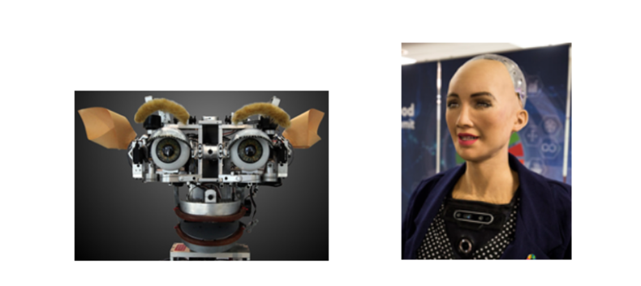

**Figure 6: Theory of Mind: Kismat and Sophia**

1. Self-Awareness

Self-Awareness system is the most advance AI which is far beyond our thoughts. This type of AI will have their own consciousness, emotions and beliefs of its own. This type of AI will suppress human and it can end human race like movies. Hopefully this type of AI doesn’t exist in reality. (Marr, What are the Four Types of AI?, 2022)

## Explanation of the topic

A collaborative filtering algorithm-based movie recommendation system is the topic I've chosen for my project. Users will be given recommendations for movies that are related to their interests and preferences. Recommender system has the ability to predict whether a particular user would prefer an item or not based on the user’s profile. Datasets are required to train the system which is taken from Kaggle. Kaggle is a cloud-based platform for data scientists and machine learning enthusiasts. It provides resources and powerful tools for learners and professionals. Kaggle offers GPU-integrated notebooks, assists in finding and publishing datasets, and enables user collaboration. (Moltzau, 2019). Many of the well-known streaming services, like Netflix, YouTube, Prime Videos, and many more, use movie recommendation systems to provide the best user experience.  recommendation systems to provide the best user experience.

The majority of individuals like to watch movies when they have free time. The movie recommendation system that this coursework will construct is like a system that predicts users’ movie preferences based on their past choice and behaviors and suggests movies that a corresponding user had watched It shows those movies/films which different viewers are watching and assumes that other viewers would watch similar movies. How does movie recommendation work? The system keeps records of the past preferences of the users and utilized that information and tries to find out similar movies and recommend those movies to users. The movie is not recommended based on rating only, there might be other factors like lead actors, directors, genre, theme, language, and many other factors. (Kniazieva, 2022)

Collaborating filtering algorithm is a subclass of an information filtering system. The information filtering system is a system that removes redundant or unwanted information from an information stream using semi-automated or computerized methods before displaying human users. Collaborative filtering filters information with the help of other users’ interactions and data collected from them. (Whitefield, 2022). It mainly focuses on the relationship between uses and items. Like when a user gave a positive review for an item they liked, the system may utilize that information to identify the user. After the information gathering of users, the system will show similar types of the products. Big organizations like GroupLens use recommendation system in order to assist users to locate articles, Amazon uses topic divarication algorisms to improve its recommendation. (Journal, 2015)

Collaborative filtering system is divided into two types which are user-based and item-based filtering system**. User-based collaborative filtering** is based on similar users and their choice and their rating of the item they already used. For example, user A gives 3 ratings to product A, 4 ratings to product B, and 5 ratings to product C out of 5 ratings. Likewise, if user B gives a 3 rating to A and 4 rating to product B then product C will be recommended to user B because the taste and rating of user A and user B are similar. (geeksforgeeks, 2020). In **item-based collaborative filtering**, products are recommended based on taste, similarities, and ratings the users had given to the similar product. In this type of technique, similarities between items are computed and similar items are displayed to users based on the similarities computed. (Saumyab271, 2021).

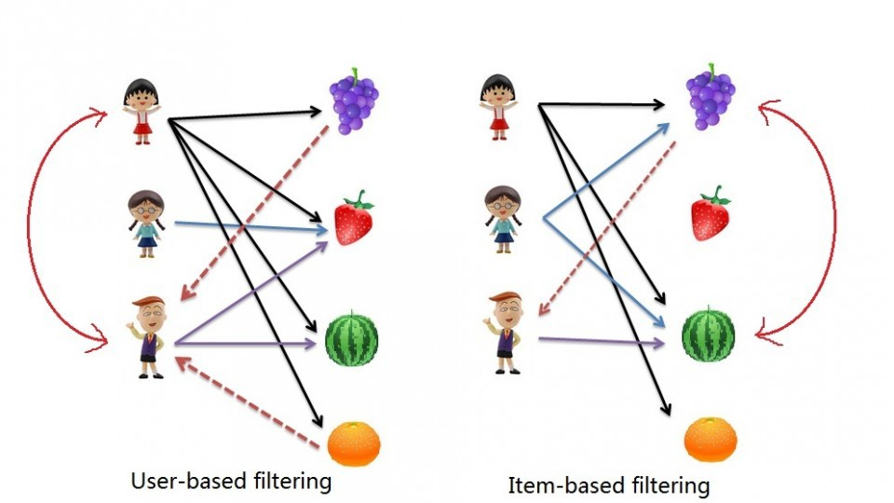

**Figure 7: Types of collaborative filtering recommendation system.**

## Explanation of the chosen problem domain

Most of the time, decisions must be made without the benefit having past information or experience. We rely on reviews of general surveys or recommendations made by other people in our everyday lives. Rapid increases in both the volume of digital information available and the number of Internet users have raised the possibility of information overload, which makes it more difficult to access online resources quickly. Likewise, generalizing a movie and assuming that everyone will like it is quite tough. (Sarika Jain, 2015) Everyone enjoys viewing movies at home, regardless of gender, age, or geographic location. Many individuals prefer romance, action, or comedy films, while others love the visions of the leading performers and filmmakers. A recommendation system has become a highly in demand technology because it can predict the needs and preferences of the user. Netflix organized the competition with the grand prize pool of US$1000000 on September 21, 2009 for developing the best recommendation system based on user rating to movies. This competition put a spotlight on the importance and requirement of recommender system in real world applications. (Basilico, 2015).

With the rapid growth of the Internet, online movie streaming technologies has gained a lot of traction in the massive extraction of data and providing better experience for the user. The movie streaming platforms and networks are expanding, the user won't be satisfied if they can't find the movies they want to watch. The consumer disliked wasting a lot of time searching for a suitable show or movie to watch. Therefore, if the system can propose a movie to them based on user behavior, taste and preferences then the user can find suitable movies for them and will engage in the system. Consequently, movie recommendation systems are incredibly helpful for users as well as service providers like Netflix and Prime Video The time required to discover a move and the problems with selection will be totally eliminated. It encourages consumers to use the system once more. (Jeong, 2013)

There are 222 million subscribers in Netflix and about 80% of them watch on Netflix movies are recommended by the recommendation system. They recommend movies based on several factors like viewing history, searches, ratings, other users’ preferences, genre, category, watching time, the device used to watch videos and may more. So. Netflix has become one of the famous streaming platforms providing hundreds of movie, animation and TV shows. (Netflix recommendation system: How it works, 2022). YouTube and other streaming platforms used their own recommendation algorithms. This report covers all the information required to develop a successful system for making movie recommendations.

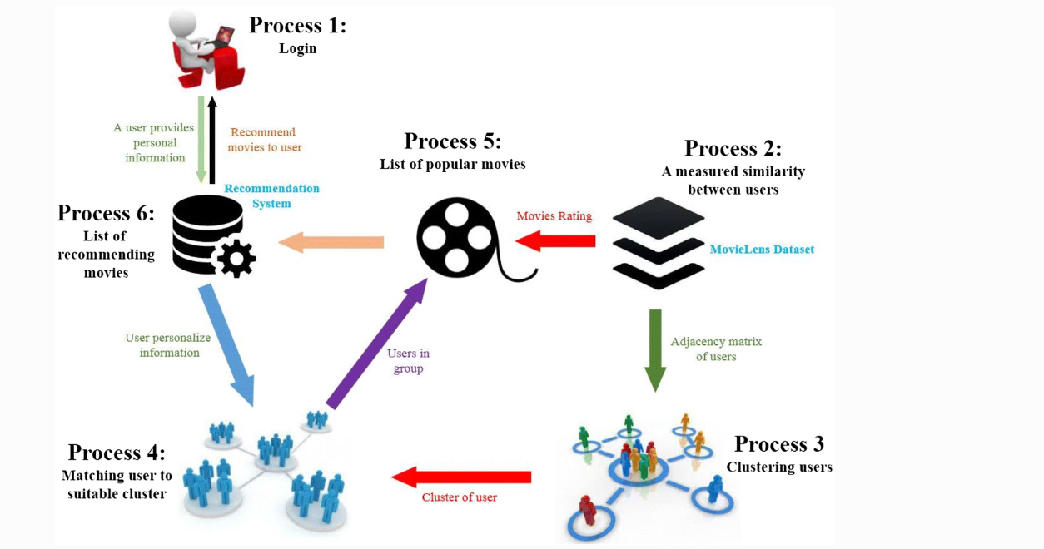

**Figure 8: Movie Recommendation system.**

# Background

Recommendation system was introduced in mid-1990s in order to help people in selecting their choice product. The concept of recommendation system was that we often believe our peers, then we reply on opinions they offer before trying something new, before watching movie, before exploring new restaurant, and even visiting doctors. In order to provide good user experience, almost every informative-intensive website has a recommender system. From Facebook to Netflix to Amazon, recommendation algorithms are at the heart of practically every online business today. For instance, when a user search product on amazon, list of similar type product is recommended, and when users listen or watch songs or videos, YouTube algorithms find the information about the reference and choice and recommend similar type in next slide. (Richa Shrama, 2016)

A movie recommendation system which filters or predict the movie based on the various factors has become the most loved recommendation system for movie lovers. Popular programming language python is used for developing the project. Python is an object-oriented, interpreted, high-level programming with full of libraries. On the basis of user behavior and past action, the system will recommend movies. The primary goal of this system is to filter and predict movies based on the user past behavior and choice. User can find the similar movies he/she wants to watch in short time period. Not only the users, it helps in productivity of product for many business and organizations.

Making this project complete and work, a lot of hard work and research with dedication is required. Websites, YouTube, tutorial, articles and journals, help from seniors and guidance of module leader is done. Some of the research and work done in this project are listed below:

## Research works

1. **Websites:**

* Website-1:

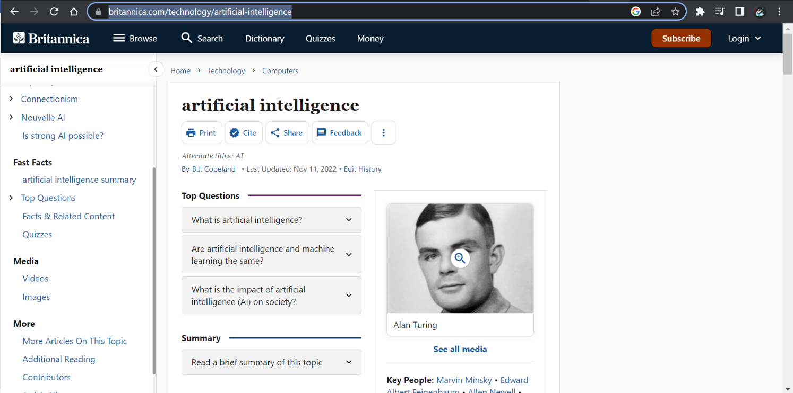

**Figure 9: Website 1.**

From this website, we can learn in-depth information about artificial intelligence. This website contains a detail introduction to AI. The first AI (chess-playing computer) was developed in the 1940s, which was the beginning of Artificial Intelligence. Along with the types of AI, the applications domain of AI is also explained. Learning outcomes from this website are:

* Introduction of AI and its types.
* The concept for movie recommendation and algorithms.
* History of AI and its evolution AI from the mid-1990s till now.
* Various application areas and technology used in AI.

<https://www.britannica.com/technology/artificial-intelligence>

* Website 2:

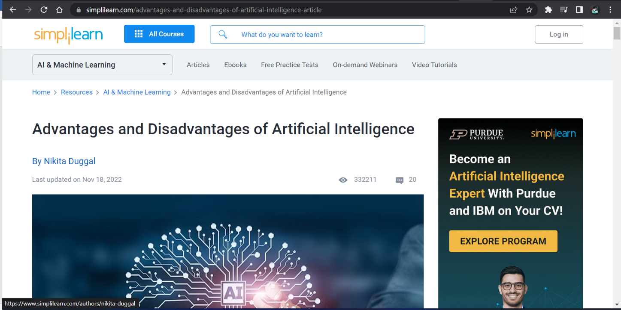

**Figure 10: Website 2 .**

This website is very helpful for my report writing and knowledge about the importance of AI. A brief description of advantages and disadvantages is discussed on this website. Learning outcomes from this website are:

* Advantages and disadvantages of AI in brief.
* How AI has improved our quality of life.
* A variety of fascinating subjects, including how AI is employed in organizations like Amazon, Facebook, and YouTube as well as self-driving cars, Siri, robots, and many more AI creations.

<https://www.simplilearn.com/advantages-and-disadvantages-of-artificial-intelligence-article>

* Website 3

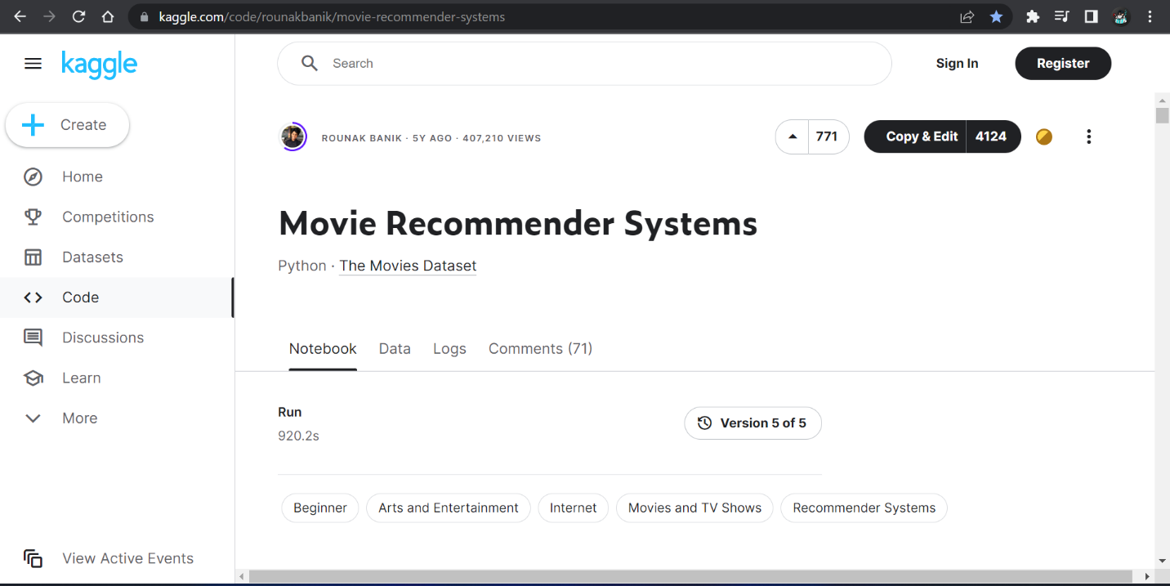

**Figure 11: Website 3.**

On this website, algorithms for developing a recommendation system such as content-based, popularity-based, and collaborative filtering are used. There are two movie datasets used in the building of the system. In my project, the datasets that are used to train the system are collected from the Kaggle websites. Implementation methods for various algorithms, such as content-based, popularity-based, and collaborative filtering, are the learning results from this article.

* Learn different python libraries like pandas, NumPy sklearn and many more.
* How datasets are read and used in the system.

<https://www.kaggle.com/code/rounakbanik/movie-recommender-systems>

1. **Articles and Journals**

* A Survey on Recommendation System

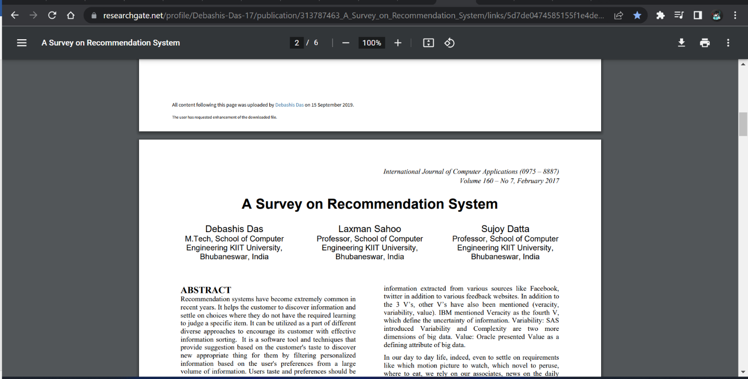

**Figure 12: A Survey on Recommendation System.**

The recommendation system and its method are described in this article. The procedures used by recommendation systems while making movie or product recommendations are based on a variety of variables, including user experience and behavior. The types of AI and its approach are also covered in this article. The most effective and simple approach to recommend the goods. This journal discusses numerous strategies for system improvement. Learning outcomes from this article are:

* Recommendation system and its approach with its advantages and disadvantages.
* Recommendation system feedback processes like Implicit Feedback Technique (IFT), Explicit Feedback Technique (EFT), and Hybrid Feedback Technique (HFT).

<https://www.researchgate.net/publication/313787463_A_Survey_on_Recommendation_System>

<https://www.researchgate.net/profile/Debashis-Das-17/publication/313787463_A_Survey_on_Recommendation_System/links/5d7de0474585155f1e4de908/A-Survey-on-Recommendation-System.pdf>

* Movie Recommender system using collaborative Filtering

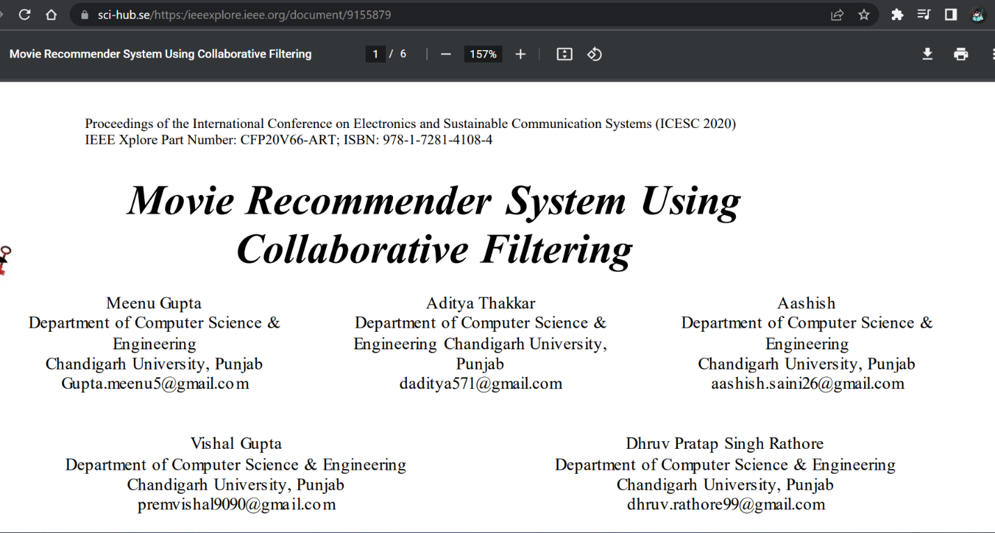

**Figure 13: Movie Recommender System Using Collaborative Filtering.**

This article is very helpful for my knowledge and project as well. The mechanism of a movie recommendation system using collaborative filtering algorithms is described here. Item-based collaborative filtering is implemented. Learning outcomes from this article are:

* Recommendation system approach like the KNN algorithm, Cosine similarity and item-based collaborative filtering is learned.
* Learn how to make flowcharts of various algorithms.
* Working mechanism of various algorithms.

<https://ieeexplore.ieee.org/document/9155879>  
<https://sci-hub.se/https:/ieeexplore.ieee.org/abstract/document/9155879>

* Recommendation systems: Principles method and evaluation

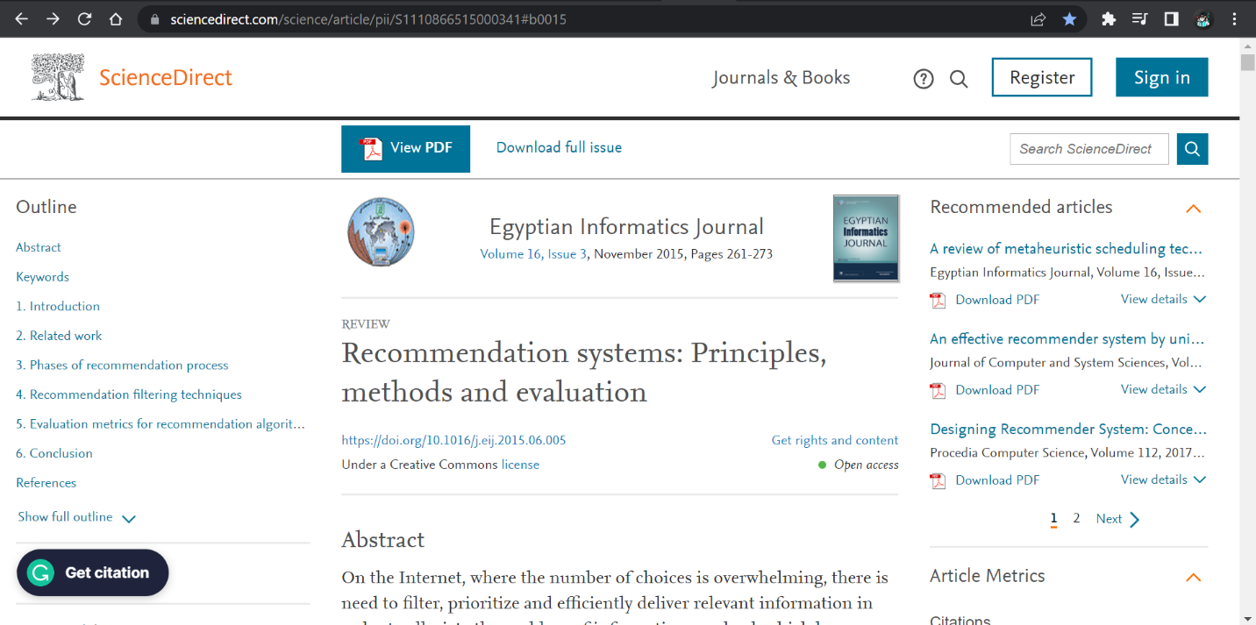

**Figure 14: Recommendation System: Principles method and evaluation.**

A quick overview of AI and its varieties is presented in this article. Various phases of the recommendation system like information collection, explicit feedback, implicit feedback, and other phases are discussed detailed. A demonstration of a flowchart of the algorithm has been presented for better understanding. Learning outcomes from this article are:

* Increasing demand for recommendation systems due to heavy digital information on the internet is discussed.
* Different phases of the recommendation process.
* A recommendation system is beneficial for both users and service providers.
* Various recommendation system users, like Ringo, amazon, News Dude, LIBRA, etc are discussed.

<https://www.sciencedirect.com/science/article/pii/S1110866515000341#b0015>

<https://sci-hub.se/https://www.sciencedirect.com/science/article/pii/S1110866515000341#b0015>

* Recommender Systems in Industry: A Netflix Case Study



**Figure 15: Recommender Systems Handbook.**

This Handbook is the most useful material for my project. Netflix prize pool competition for developing the best recommendation system is discussed. Many recommendation approaches were developed. Proper utilization of user data in recommendation systems contributes to the evolution of industrial applications of recommender systems. The main motive of this handbook is to provide an up-to-date overview of recommender system techniques used in the industrial.

<https://link.springer.com/chapter/10.1007/978-1-4899-7637-6_11>

<https://sci-hub.se/https://link.springer.com/chapter/10.1007/978-1-4899-7637-6_11>

* An improved content based collaborative filtering algorithm for movie recommendations.

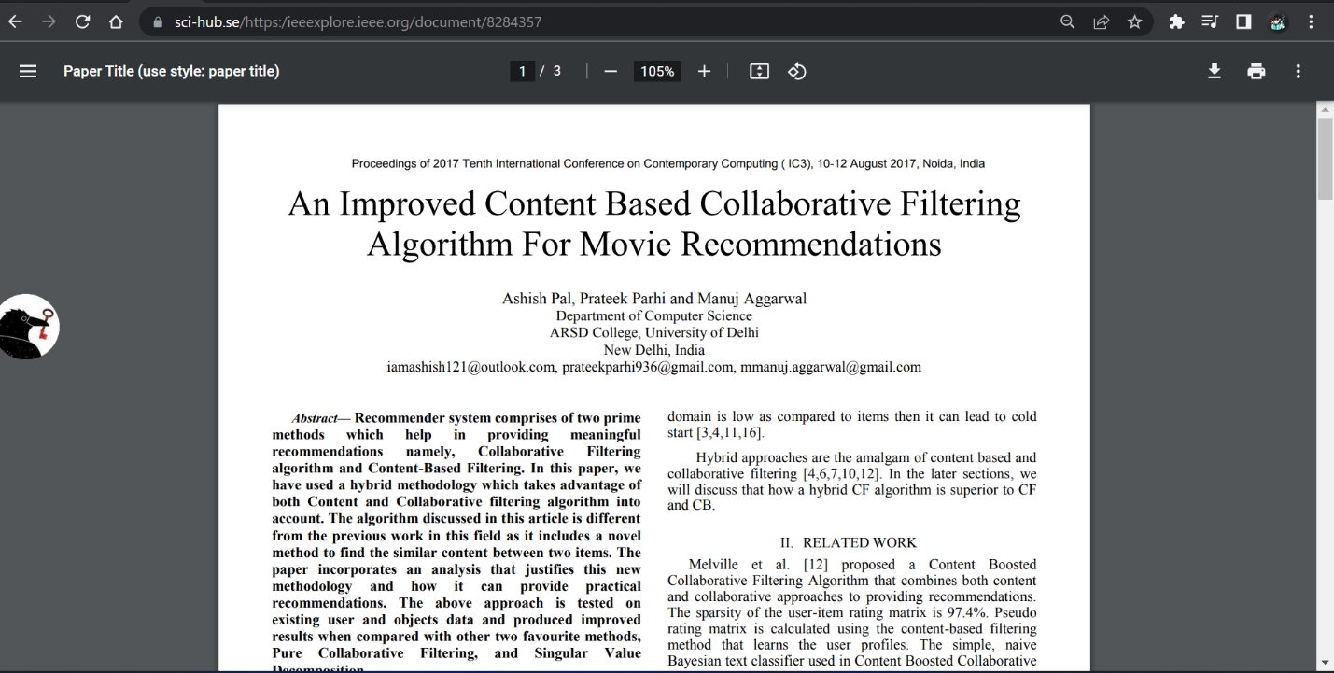

**Figure 16: An improved content based collaborative filtering algorithm for movie recommendations.**

The focus of this article is on a hybrid technique for movie recommendations that makes use of both collaborative and content filtering algorithms. This journal describes the new approach and make comparison with the Collaborative Filtering and Singular Value Decomposition. It explains the hybrid technique and how it can provide practical recommendation. It presents a novel approach to content-based filtering by depicting a simple correlation between two features using intersection.

<https://ieeexplore.ieee.org/document/8284357>

<https://sci-hub.se/https://ieeexplore.ieee.org/document/8284357>

## Review and Analysis of existing work in the problem domain

1. Netflix

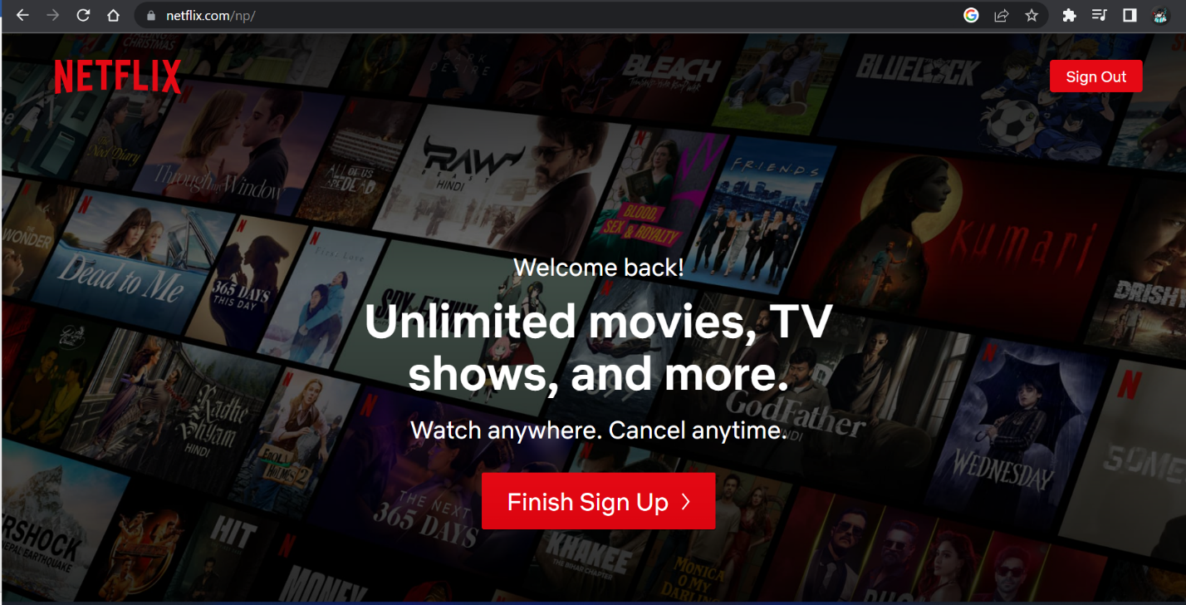

**Figure 17: Netflix**

On August 29, 1997, Reed Hastings and Marc Randolph launched Netflix, one of the most popular streaming services, with the goal of offering every type of movie, documentary, TV show, drama, and mobile game. The effectiveness and growth of the recommendation system are due to Netflix. After the biggest prize competition of building a recommendation system, many systems were developed and knowledge about the recommendation system started boosting. Netflix is a subscription-based online streaming company. They charge a certain amount for watching movies. Users are recommended based on the user’s previous behavior. They collect every information about the users and utilized them to recommend movies to users. I am one of the users of Netflix, and I like to watch action and anime. Netflix mostly recommends action movies and anime in my profile.

1. Amazon prime video

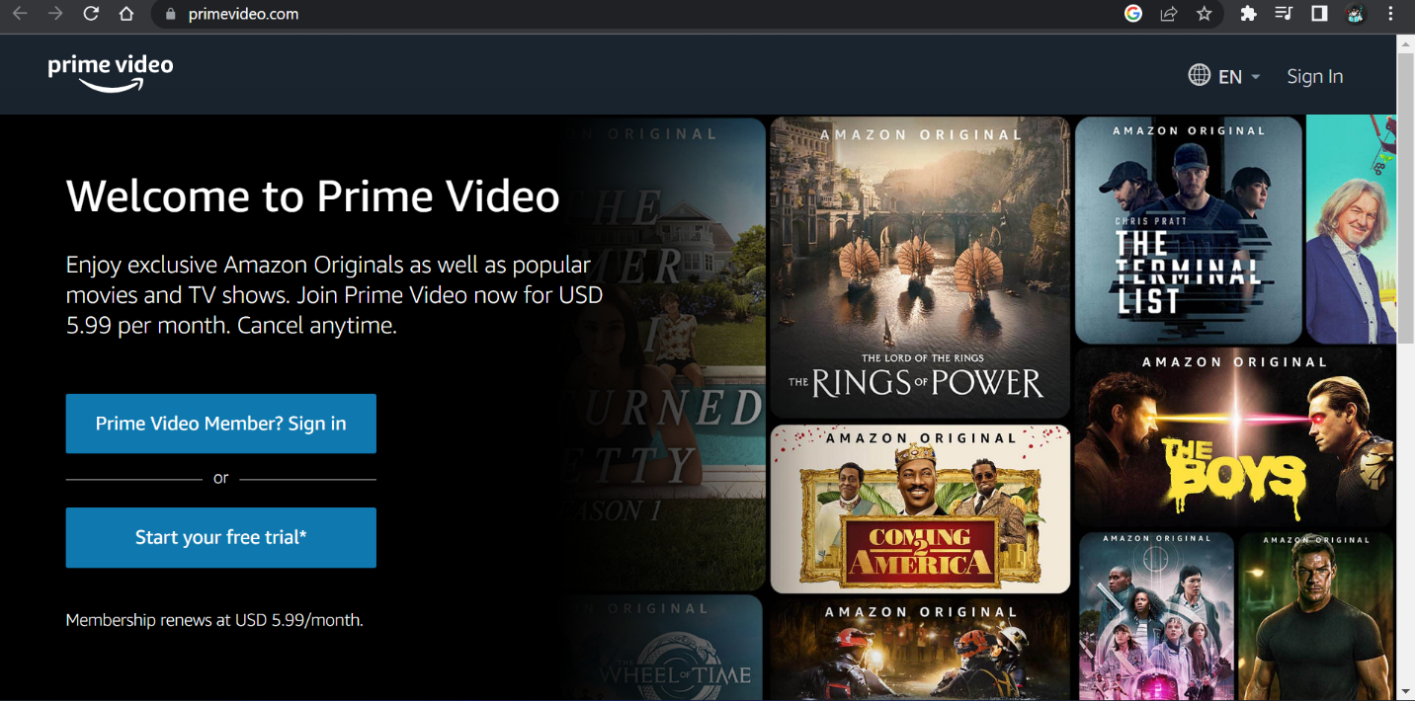

**Figure 18: Prime Video**

Amazon prime video is one the best competitors of Netflix, founded on September 7, 2006. Prime Video is also a subscription streaming company where a variety of movies, TV series, dramas, and documentaries. Like Netflix, prime video offers movies to those users who have a subscription. Many exciting films and movies are recommended to users on various factors like genre, actors, time of watch, story theme, music, and many more. They also use a recommendation system for good productivity and the user's best experience. Users can watch whatever movies in different languages after paying a certain charge.

1. MyFlixer

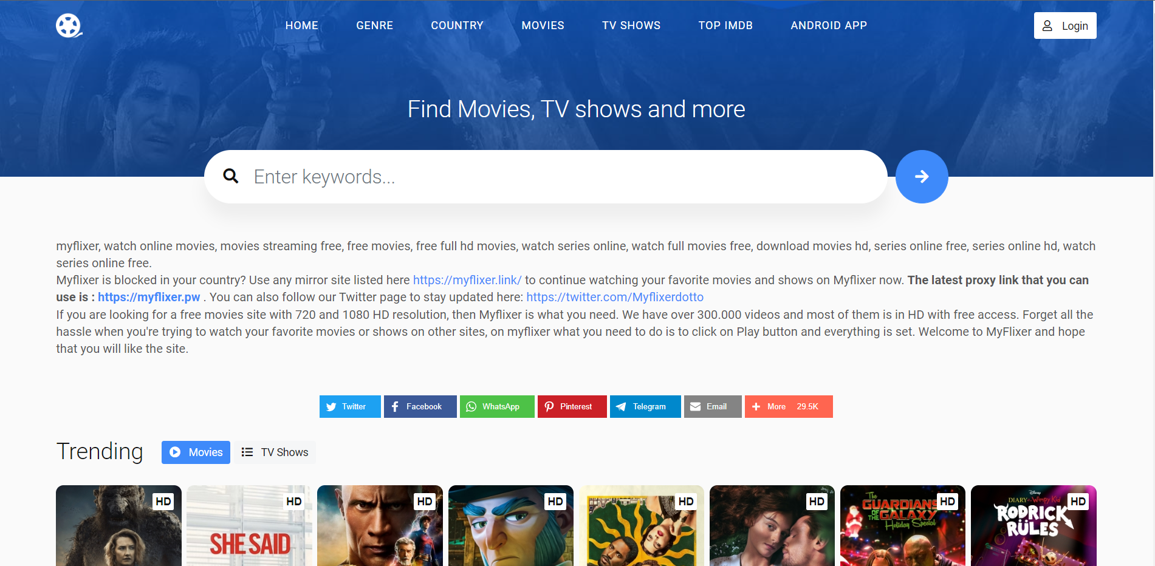

**Figure 19: MyFlixer**

When it comes to watch movies for free, MyFlixer is the best solution. It provides online movies, streaming, series, and drama for free which are in others paid streaming service providers like Netflix, amazon prime video. This website offers the latest and trending movies to users. I have been using this website since my other service provider subscription failed. This website recommends movies that you like to watch and also the latest released movies.

1. Flickmetrix

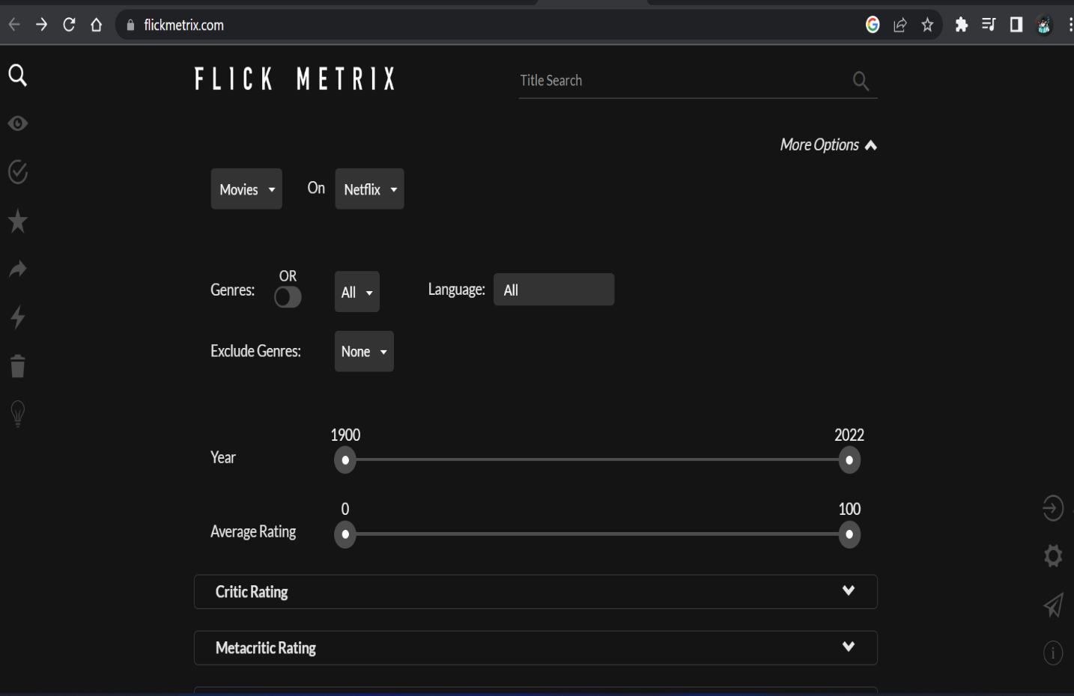

**Figure 20: Flickmetrix.**

Flickmetrix is the best site for finding films when you know your choice and preference. Users are able to filter movies depending on their personal preferences. t offers a wide range of movie selection choices. There are other filtering choices, including letterboxed, Rotten Tomatoes, Metacritic, and IMDb (Internet Movie Database) ratings. Search fields are also available where you can explore movies by title, directors, casts, and plots. With that information gathered, users are provided additional features where users can search by sorting movies on the rating other users had given. Users can also see their data like a watchlist, seen movies, liked movies, favorite movies, and recommended movies. Users are given the privilege to select streaming services to watch movies, such as Netflix, Amazon price, Disney+, HBO, and so on.

1. Wewatch

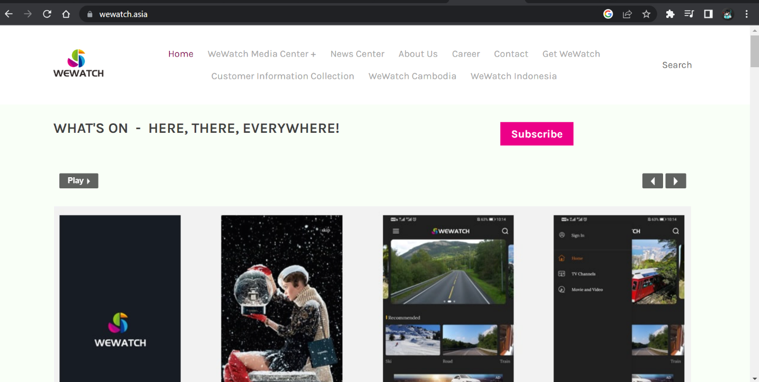

**Figure 21: WeWatch**

WeWatch is a South East Asian streaming service provider where we can see live TV and videos to our taste. It also offers e-learning, sports, and e-gamming live streaming. For those who love to watch live videos or streaming, it makes it easier by suggesting content related to your preferences. We can search our favorite movies by genre, streaming sites, streamers, language, and many more. I personally like WeWatch to see live streams of various e-games.

1. Movie of the night

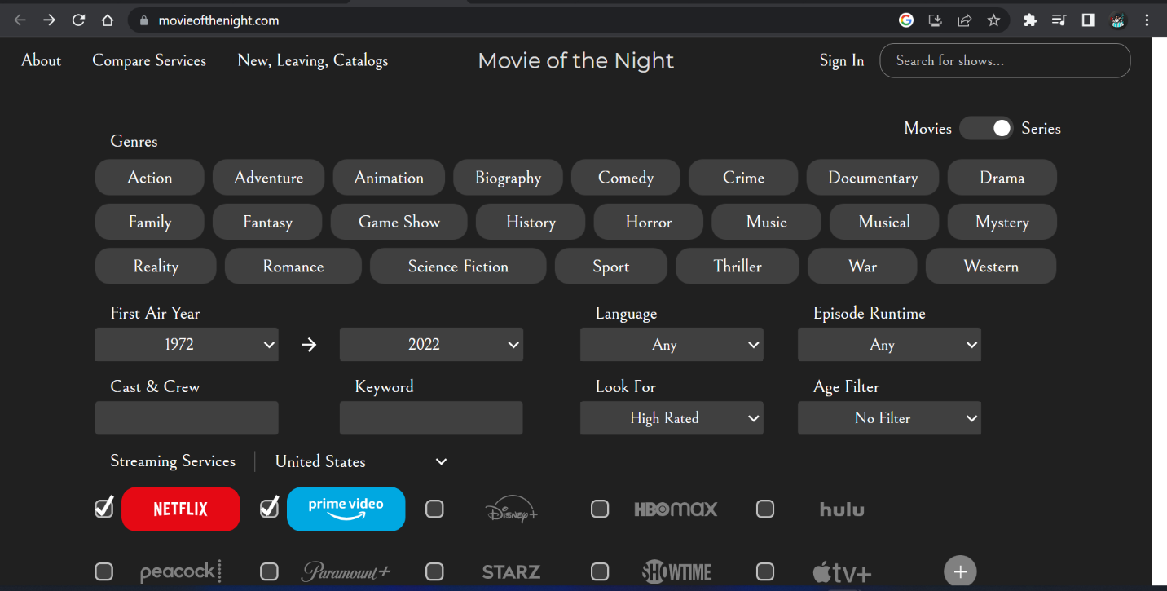

**Figure 22: Movie of the night.**

Movie of the night is also a movie recommendation-based website. Users are given full access to choose their movie type. Users can choose movies with a variety of options such as genres, first air year, language, Episode runtime, cast and crew, keyword, rating, and age filters. Like other recommendation systems, movie of the night also provides the privilege of selection streaming services based on the country they live. Users can also choose between movies or series they want to watch.

1. Zoro.to

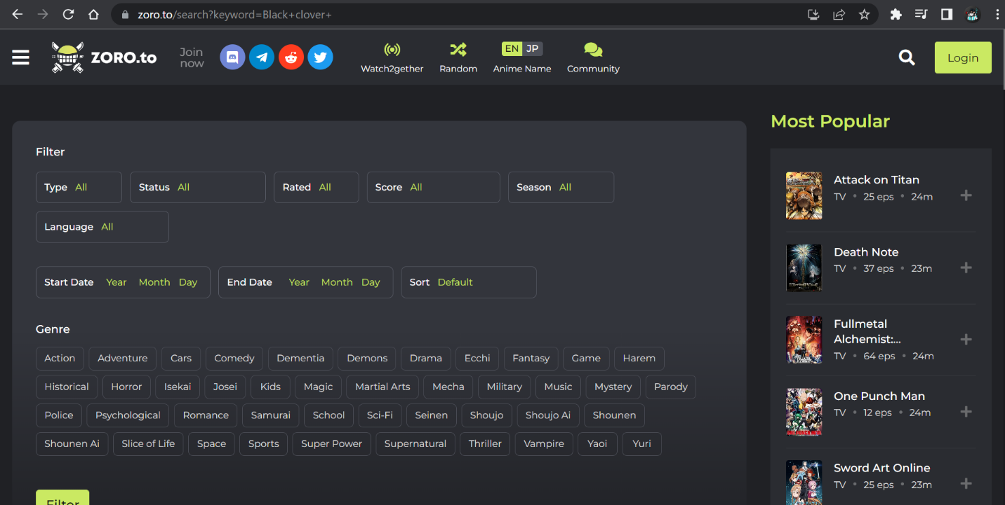

**Figure 23: Zoro.to**

For those who love to watch anime, zoro.to is the best option to explore. It has thousands of anime in its native language and dubbed language. I love this site and started using it for more than 6 years for watching anime. Mostly I like to watch anime with short episodes and action-related anime. Zoro.to recommend anime with lesser episodes and action related.

# Solution

## 3.1 Explanation of the proposed solution/approach to solving the problem

The following are some of problem arise during the development of a movie recommendation system and with their solution:

* Sparse matrix:

Spare matrix is those matrices which is made of zero value in dataset. It is not sure that all the users will gives ratings to every movie. Hence, it creates sparsity in datasets. Ratings are very sparse and data points are collected from most popular movies and highly engaged users. Those kinds of data increase space complexity as system is exposed to increase the memory usage for storing data. While running the operations like addition or multiplication of two sparse matrix, it might take long period of time. It increased the size of matrix which leads to time complexity problem. The reduce the sparsity problem in dataset, crs_martrix function from the spicy library will be implemented in this project.

* Cosine Similarity:

Cosine similarity is the cosine of the angle between two points. It is used in KNN classification for finding optimal number of neighbors. It is used to measure the similarity between two contents. Due to the high dimensionality of our training set, KNN must perform a significant amount of work, which diminishes its performance. There are several approaches to solve this problem, but Cosine similarity is the best solution for this problem.

## Explanation of AI Algorithms used

Recommendation system, fraud detection, spam filtering, malware threat detection is some of the use case of machine learning. Machine learning is defined as a type of AI that helps other software or system for predicting outcomes accurately. Various big companies like Facebook, Google, twitter, are using machine learning as a central part of their operations. (Burns, nd) This proposed “Movie Recommendation system” is based on collaborative filtering technique which is way accurate and more efficient to use and K Nearest Neighbors (KNN) algorithms is used to determine the distance between the target movies with other movies in the dataset and using cosine angle similarity top k nearest similar movies are ranked at top.

* Collaborative Filtering

In this type of recommendation system item are recommended through by information filtering according to user interest with other users having matching similarities in items and users. The information about the users and items are compared and recommends similar types of product. In movie recommendation systems, movies are recommended based on the user information and other similar types of user’s information. For instance, user characteristics like age, gender, and nationality are determined using collaborative filtering in movie recommender systems. With the use of these attributes, movie suggestions are generated that correspond to individuals with identical demographic attributes and prior user search history.

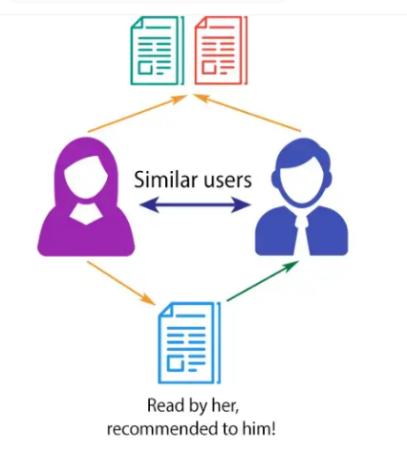

**Figure 24: Collaborative Filtering**

* K Nearest Neighbor (KNN)

KNN is a well-known recommendation algorithm system due to its faster prediction capabilities and low data processing duration. It is based on supervised learning technique mostly used for classification as well as regression. Data are classified using KNN classifier where some input values trains systems and predict the outputs. This type of algorithms stores all the available information and new data are compared based on similarities measures. The K-NN method assumes similarity between the new case and the existing cases and places the new case into the category that is most similar to the existing categories. KNN is known as non-parametric algorithms because it does not make assumptions on underlying data.

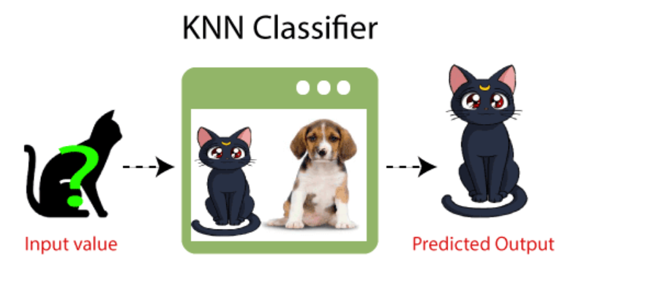

**Figure 25: KNN Classifier.**

Abbreviation of KNN is K Nearest Neighbor. K and KN is a parameter that refers to the number of nearest neighbors include in the majority of the voting process. KNN algorithms is based on features similarity, choosing the right value of “K” is a process called parameter tuning and is important for better accuracy. While choosing value of “K” following thing are focused:

* Sqrt(n), where n is the total number of data.
* Odd value of K is selected to avoid confusion between two classes of data.

KNN algorithm is used when data is labeled that what labeled contains what data. Data should be noise free because KNN is a lazy learner algorithm, it doesn’t learn a discriminative function from the training data sets. New data are compared to existing dataset and classified based on similarity. In KNN, nearest neighbor is calculated by Euclidean distance formula, a simple geometric formula to calculate the distance between tow nodes in graph. According to the Euclidean formula, the distance between two point with A (x1, y1) and B (x2, y2) coordinate is dist(d) = √ [(x22 – x11)2 + (y22 – y11)2]. Euclidean distance of unknown data point from all the points of dataset and place to nearest neighbor.

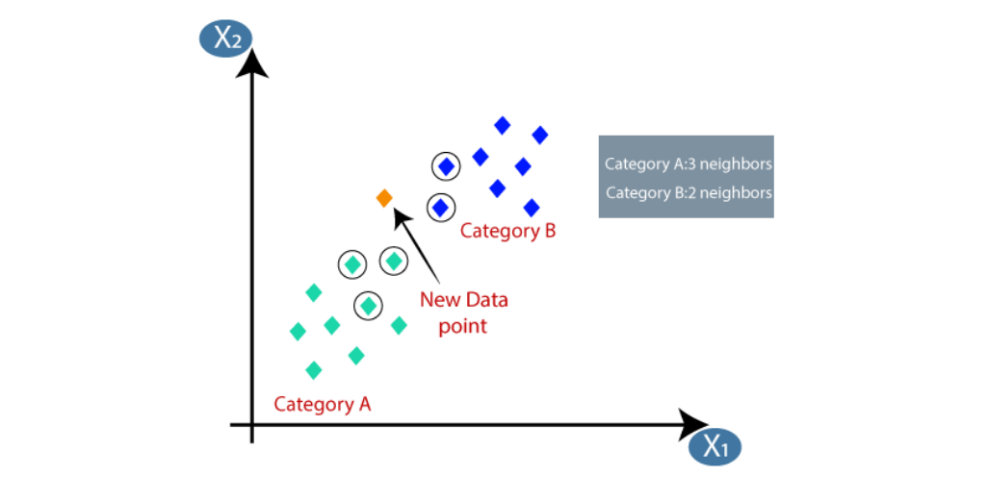

**Figure 26: K Nearest Neighbor (KNN)**

Two groups of datasets are represented in the graph above, each of which is colored differently. The yellow diamond is an unknown data point that must be sorted into the most similar group to which it belongs. The set value of K must be odd number for accurate outcomes. In the above graph, suppose we set the value of K = 3, the mostly like group will be green and the yellow diamond will be group with green diamond. Some of advantages and disadvantages of KNN algorithms are:

**Advantages:**

* This algorithm is quite simple, easy to execute and faster predicting ability.
* This algorithm is versatile as it can be used for both classification and regression.
* As there is no training time, it evolves with new data.

**Disadvantages:**

* Quality of data determines the outcomes accuracy.
* KNN store the data, so it required high memory.
* Calculating the distance between the data points for all the training existing datasets required high processing cost.

Implementing this algorithm includes following steps:

* The initial step of implementing this algorithm requires a dataset.
* Choose the nearest data point value which is “K” which need to be positive odd integer value.
* Calculate distance between unknow point with existing point using distance formula, Euclidean method is most preferred.
* Based on distance value sort dataset in ascending order.
* After sorting datasets from small to large, pick first K data.
* The unknown data will be classified based on the most repeated dataset.

## 3.3 Pseudocode

Pseudocode is a most often word in filed of programming and algorithms that’s helps programmers develop algorithms. Pseudocode is a text-based readable description od what computer program and algorithms will do. Pseudocode means false code that reflects the program but itself is not a program. While developing pseudocode, it should be considered that other programmer and reader must understand and can write code in any language. (Ubah, 2021)

The proposed solution's movie recommendation system's pseudocode is shown below:

**3.4 Diagrammatic Representation**

1. State Transaction Diagram

State diagram is a model or diagram for easy understanding for users or in technical term it is a diagram used to represent a state of machine. It describes all the states that an object can have. The system receives events or input and cause the machine to transition from one state to another. Events can trigger a state transition unless a Boolean expression is true. (Copeland L. , 2003)

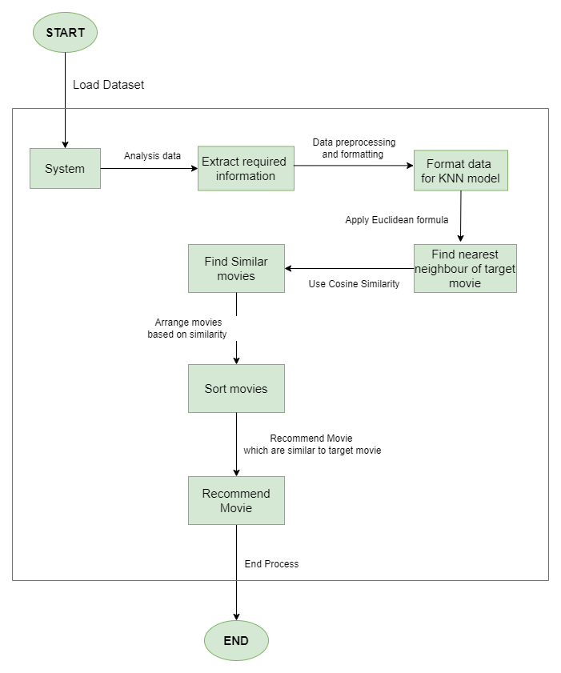

**Figure 27: State Transition Diagram.**

2. Flow chart

A flowchart is a diagram that shows a diagrammatical representation of a process, system, or computer. This diagram is easy to understand and helps in documenting, studying, planning, improving, and communicating various problem domains. The symbols used in flow charts are:

* Ellipse symbols are also known as terminator symbols that identify the start and end.
* An arrow is a line connector that describes the relationship between two components.
* The diamond symbol is a decision symbol that makes decisions based on the Boolean symbol (true/false).
* The rectangle symbol is a process symbol that represents process action and operation.
* Parallelogram symbols represent input and output.

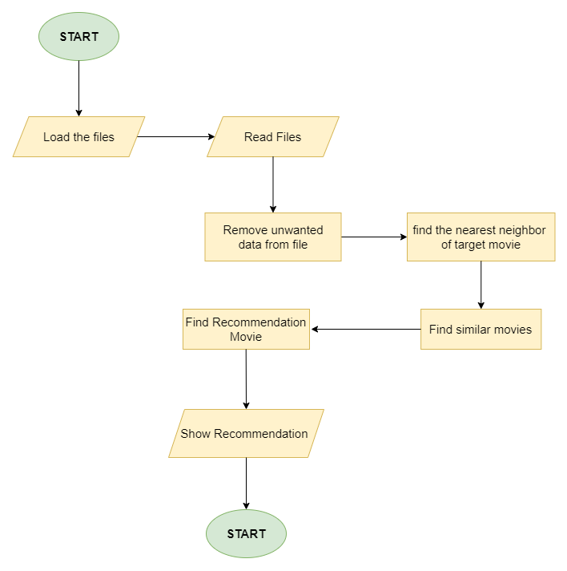

**Figure 28: Flowchart**

# 4. Conclusion

## 4.1 Analysis of work done

This topic carries a sort of work done for the project “Recommendation system”, the topic I have chosen for AI coursework. The first part of the coursework carried the description of chosen topic and research done. The report contains a details description of AI, types of AI, recommendation system, recommendation system approach, and algorithms used for developing the project. The research part includes books, journals and articles, websites, and research papers from various sources. It also contains the analysis of various similar systems and applications to our project. Pseudocode of algorithms and diagrammatical representation like flowcharts and state transition diagrams are done in the initial development phase. The reporting and research done in this coursework provide ideas and concepts for developing of system.

## How the solution addresses the real-world problem

The rapid expansion of the internet has increased abundant information and data creating difficulties for individuals and companies to choose between various products and contents. It cost lots of time in searching, which is not a positive sign for production companies and is not practical for users. Recommendation systems solve this problem domain, by analyzing the large volume of dynamically generated information on the internet. It can predict, individuals prefer items based on various factors which are available in large amounts on the internet. It filters the information and provides personalized content and service to users.

A few years back, people rarely got opportunities to watch TV shows and movies of their preferences. People used to watch movies in a single medium which didn’t satisfy their needs. Watching repeated shows and movies continuously makes them tired and dissatisfied. It diminishes the user interaction with the service provider. Users demand the content or items which they are searching for and want to watch. Nowadays every corner of the world has internet access. The Internet can store every information about us, they know where we go, our interests, and what we will do next. Without a recommendation system, it won’t happen. Recommendation systems keep track of users’ behavior, requirements, and needs. Information like the customer’s present site use and his previous browsing history, a recommendation system can deliver your preferred movies and shows. It helps to increase interest in content, which is beneficial for a service provider. Without a movie recommendation system, people can’t find movies and shows according to their interests. It helps in the economic growth of various streaming and service provider companies like Netflix, prime Video, hot star, etc.

## 4.3 Further work

The reporting and research analysis part of the project on movie recommendation system is completed. After this, we have to build a working prototype of the chosen topic ‘movie recommendation system’. Famous and advance programming language python is used for developing the system along with the widely used collaborative filtering approach and strong algorithm K-nearest neighbor.

## 

# References

Basilico, X. A. (2015). Recommender Systems in Industry: A Netflix Case Study. *Recommender Systems Handbook* , 385-491.

Biswal, A. (2022, October 14). *7 Types of Artificial Intelligence That You Should Know in 2023*. Retrieved from simplilearn.com: https://www.simplilearn.com/tutorials/artificial-intelligence-tutorial/types-of-artificial-intelligence

Biswal, A. (2022, October 14). *7 Types of Artificial Intelligence That You Should Know in 2023*. Retrieved from simplilearn.com: https://www.simplilearn.com/tutorials/artificial-intelligence-tutorial/types-of-artificial-intelligence

Burns, E. (nd, nd nd). *machine learning*. Retrieved from techtarget: https://www.techtarget.com/searchenterpriseai/definition/machine-learning-ML

Copeland, B. (2022, November 11). *artificial intelligence*. Retrieved from britannica: https://www.britannica.com/technology/artificial-intelligence

Copeland, L. (2003, January 28). *State-Transition Diagrams*. Retrieved from stickyminds.com: https://www.stickyminds.com/article/state-transition-diagrams

Duggal, N. (2022, November 18). *Advantages and Disadvantages of Artificial Intelligence*. Retrieved from simplilearn: https://www.simplilearn.com/advantages-and-disadvantages-of-artificial-intelligence-article

FRANKENFIELD, J. (2022, July 06). *Artificial Intelligence: What It Is and How It Is Used*. Retrieved from investopedia: https://www.investopedia.com/terms/a/artificial-intelligence-ai.asp

Frankenfield, J. (2022, January 01). *Weak AI*. Retrieved from investopedia: https://www.investopedia.com/terms/w/weak-ai.asp#:~:text=Weak%20AI%20helps%20turn%20big,that%20answers%20users'%20spoken%20questions.

geeksforgeeks. (2020, July 16). *User-Based Collaborative Filtering*. Retrieved from geeksforgeeks.com: https://www.geeksforgeeks.org/user-based-collaborative-filtering/

Jeong, W.-H. K.-J.-S. (2013). Performance Improvement of a Movie Recommendation System based on Personal Propensity and Secure Collaborative Filtering. *Journal of Information Processing Systems*, 157-172.

Journal, E. I. (2015). Recommendation systems: Principles, methods and evaluation. *Egyptian Informatics Journal*, 267-273.

Kniazieva, Y. (2022, April 14). *What Is a Movie Recommendation System in ML?* Retrieved from labelyourdata.com: https://labelyourdata.com/articles/movie-recommendation-with-machine-learning

Lateef, Z. (2022, November 22). *Types Of Artificial Intelligence You Should Know*. Retrieved from edureka.com: https://www.edureka.co/blog/types-of-artificial-intelligence/

Marr, B. (2021, May 20). *What is Striong (General) AI? Here Are 9 Practical Examples.* Retrieved from linkedin: https://www.linkedin.com/pulse/what-strong-general-ai-here-9-practical-examples-bernard-marr/

Marr, B. (2022, July 02). *What are the Four Types of AI?* Retrieved from bernardmarr.com: https://bernardmarr.com/what-are-the-four-types-of-ai/

Moltzau, A. (2019, December 08). *What is Kaggle?* Retrieved from medium.com: https://medium.com/dataseries/what-is-kaggle-4751e384e916

*Netflix recommendation system: How it works*. (2022, April 05). Retrieved from recoai.net: https://recoai.net/netflix-recommendation-system-how-it-works/

Richa Shrama, R. K. (2016). Evolution of Recommender Systems from Ancient Times to Modern Era: A Survey. *Indian Journal of Science and Technology 9(20)*, 1-12.

Sarika Jain, A. G. (2015). Trends, problems and solutions of recommender system. *Trends, problems and solutions of recommender system*, 955-958.

Saumyab271. (2021, May 25). *Item-based Collaborative Filtering : Build Your own Recommender System!* Retrieved from analyticsvidhya.com: https://www.analyticsvidhya.com/blog/2021/05/item-based-collaborative-filtering-build-your-own-recommender-system/

Whitefield, B. (2022, August 29). *What is collaborative Filtering: A simple Introductiion*. Retrieved from builtin.com: https://builtin.com/data-science/collaborative-filtering-recommender-system

## 